Investigations into celestial escapades
John Little
Lillian Thurman
2024-02-14
Abstract
Based on Quarto Manuscript work by Posit.co, C.Wickham, Purves, and Cockett, et. al.: Lorem ipsum dolor sit amet, consectetur adipiscing elit, sed do eiusmod tempor incididunt ut labore et dolore magna aliqua. Ut enim ad minim veniam, quis nostrud exercitation ullamco laboris nisi ut aliquip ex ea commodo consequat. …

1 Introduction
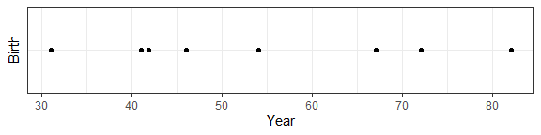
Figure 1: Timeline of Births in Star Wars
Based on data up to and including 2019, births in the Star Wars multiverse can be said to happen every 7.3 years on average.
In an unrelated gambit to emulate a fashion of scholarly writing, this author references Lipset (1960). Lipset discussed the nature of democracy and the role of party representation. His paper highlights the difference in understanding of democracy between sociologists and laymen. While public opinion often emphasizes the freedom of citizens to elect representatives, sociologists focus on the social processes and elites that influence these democratic systems.
A sampling of eight births were recorded since star-date zero (Figure 1).
Data and methods are discussed in Section 2.
Let $x$ denote the number of births in a year. Then, $x$ can be modeled by a Poisson distribution
$$p\left(x\right)=\frac{e^{−λ}λ^{x}}{x!} \left(1\right)$$
where $λ$ is the rate of births per year. Using Equation 1, the probability of a birth in the next $t$ years can be calculated.
Below is a table generated from a data frame and presented via the {gt} package
Table 1: A table of Star Wars characters and their birth years
name | birth_year
Darth Vader | 41.9
Lando Calrissian | 31.0
Ackbar | 41.0
Padmé Amidala | 46.0
Mace Windu | 72.0
Palpatine | 82.0
Bail Prestor Organa | 67.0
Darth Maul | 54.0
However, as the situation demands, more basic tables can be presented with Markdown.
Table 2: Minor Star Wars characters and their hair color
Name | Hair Color
Adi Gallia | none
Dormé | brown
Zam Wessell | blonde
Taun We | none
Jocasta Nu | white
Shaak Ti | none

Table 1 lists the birth years of a sample of Star Wars characters. Meanwhile, Table 2 summarises Minor Star Wars characters and their hair color.
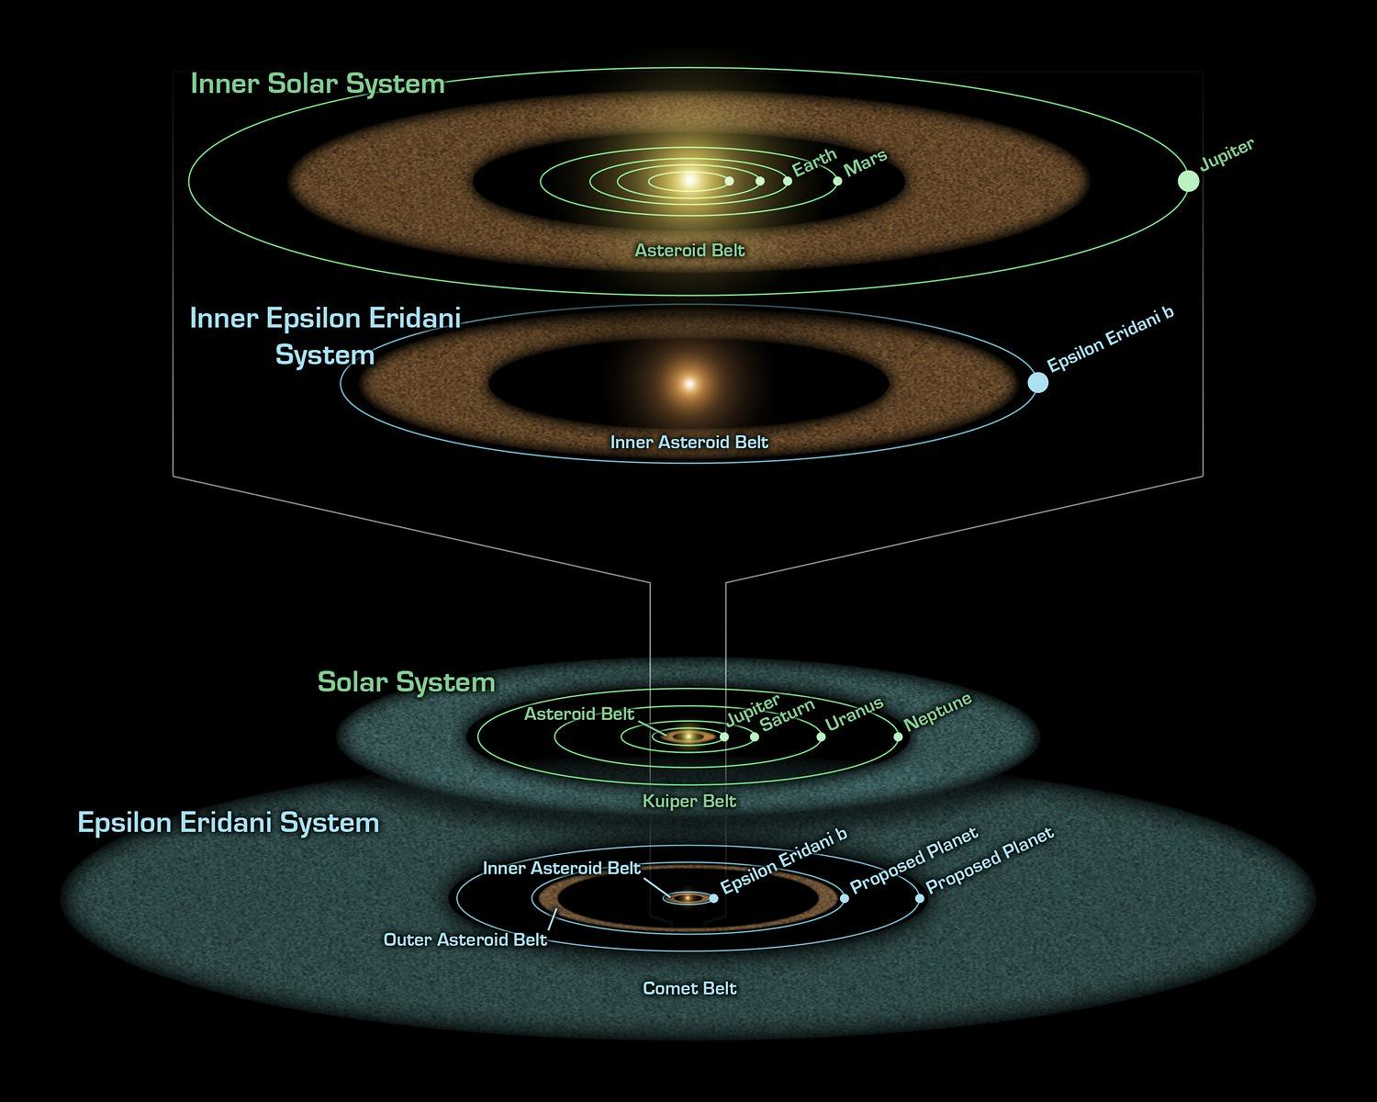
Figure 2: The Epsilon Eridani system
Epsilon Eridani is visible from most of Earth’s surface. Located at a distance 10.5 light-years (3.2 parsecs) from the Sun (Figure 2).
Also notable is the ability to perform calculations in notebooks. This means multiple computation notebooks can be used in a project. Outputs and artifacts of those notebooks, then, can be embedded in the main manuscript page, or other notebooks. Below Figure 3 is an embedded figure derived from a separate notebook file.
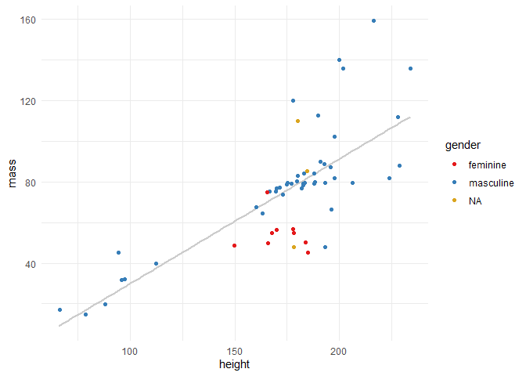
Figure 3: Starwars characters: mass over height
Figure 3 shows the relationship of mass over height for a sample of _Star Wars* characters.

2 Data & Methods

3 Conclusion
(A), Let’s not forget how cool Figure 1 is. But, (B), don’t forget (A).

4 Slides
my slides

References
Lipset, Seymour Martin. 1960. “Party Systems and the Representation of Social Groups.” European Journal of Sociology 1 (1): 50–85. https://doi.org/10.1017/s0003975600000059.

